1. List the ordno and dollars of all orders.

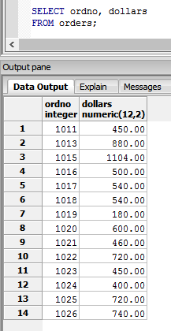

1. List the name and city of agents named Smith.

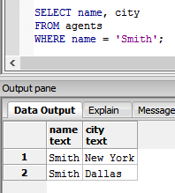

1. List the pid, name, and priceUSD of products with quantity more than 208,000.

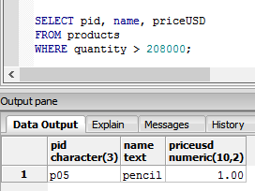

1. List the name and cities of customers in Dallas.

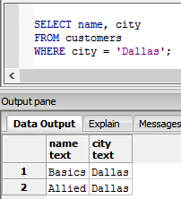

1. List the names of agents not in New York and not in Tokyo

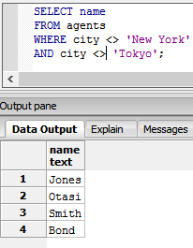

1. List all data for products not in Dallas or Duluth that cost US$1 or more.

